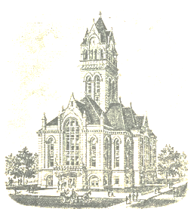
________________________________________________________________________
Bernadette Manuel, Clerk

Starke County Clerk’s Office

Phone: 574-772-9128

53 East Washington Street, PO Box 395, Knox, Indiana 46534

________________________________________________________
FEDERAL AGENCY:
US ELECTION ASSISTANCE COMMISSION
DIRECT: 301-563-3919
TOLL FREE: 866-747-1471
STATE AGENCIES:
INDIANA ELECTION DIVISION
DIRECT: 317.232-3939
TOLL FREE 800-622-4941
INDIANA SECRETARY OF STATE
DIRECT: 317-232-6531
INDIANA REPUBLICAN STATE CENTRAL COMMITTEE
DIRECT: 317-635-7561
TOLL FREE: 800-466-1087
INDIANA DEMOCRATIC STATE CENTRAL COMMITTEE
DIRECT: 317-231-7100
TOLL FREE: 800-223-3387
STARKE COUNTY ELECTION BOARD:
MARCIA BEDROCK: PRESIDENT REPUBLICAN CHAIRMAN
JEFF HOUSTON: DEMOCRATIC CHAIRMAN
BERNADETTE MANUEL: COUNTY CLERK/CEB SECRETARY
STARKE COUNTY ELECTION OFFICE: 574-772-9160

